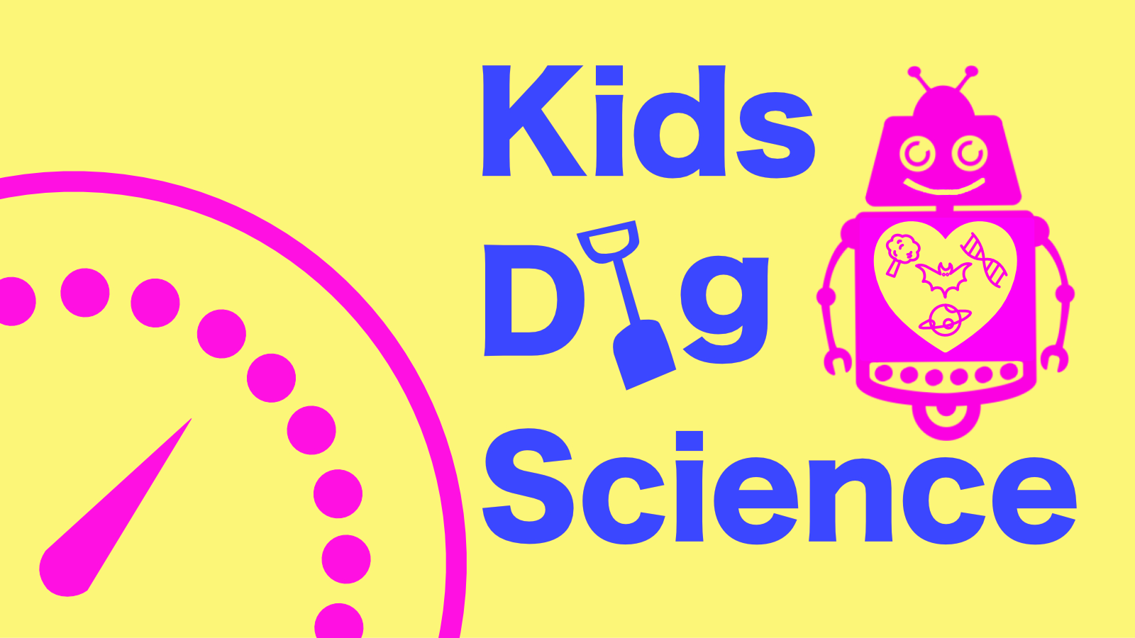

Kids Dig Science, by the Malta Chamber of Scientists is launching its new shows for Spazju Kreattiv’s Ziguzajg 2020-2021, on the 19 December.

This season we will tackle new and exciting topics such as insects, genes, flight, cognitive behaviour and black holes. Tough stuff but breaking scientific concepts and knowledge down for all to understand, is what we do best. We encourage critical thinking and problem solving skills during the puppet shows which are designed to be funny and entice as much interactivity as possible, from kids between the ages of 6 and 10.

Itinerary - Saturdays at 3pm:
December 19, 2020 Insects
February 6, 2021 Celebrating Diversity (Genes)
March 6, 2021 Learn to Fly
April 10, 2021 Deepest Darkest Black (Black Holes)
May 1, 2021 Read my Mind (Cognitive Science)
Book your tickets here
Spazju Kreattiv has set up a number of measures to ensure this is a safe experience. Distanced seats, temperature taken at the door, people will not be able to mill around or queue inside the building but will be asked to take their seats immediately, the rooms are thoroughly sanitised after every performance.

